Meet Olympia City Council candidate Sarah Destasio
BY BRANDON BLOCK
MAY 24, 2021 05:45 AM,
UPDATED MAY 24, 2021 07:58 AM

Sarah Destasio is running for Olympia City Council Position 6 being vacated by Renata Rollins. Corey Gauny and Dontae Payne also seeking the seat, so there will be an Aug. 3 primary to winnow the field. COURTESY OF SARAH FOR THE CITY
Editor’s note: This is one in a series of interviews with candidates running for Olympia City Council. At the end of each interview, The Olympian asked every candidate two questions: what they pay in rent or mortgage, and if they could correctly state the median home sale price in Olympia, which is $430,000.
Olympia City Council candidate Sarah Destasio is a former co-chair of the Olympia chapter of the Democratic Socialists of America, which has endorsed her along with fellow candidate Talauna Reed. Destasio is a co-founder of Capital Homecare Cooperative, a worker-owned caregiving agency.
Destasio is running for Olympia City Council Position 6 being vacated by Renata Rollins. Corey Gauny and Dontae Payne also are seeking the seat, so there will be an Aug. 3 primary to winnow the field.
In an interview with The Olympian, Destasio said that supporting workers and worker-owned businesses are a central focus for her. She cited ideas like a city minimum wage and “predictive scheduling” rules, which she said were first proposed by council member Jim Cooper more than five years ago but failed to pass.
Destasio declares on her website that “housing is a human right,” and wants stronger protections for renters, including requiring just cause for evictions (which recently passed on the state level), creating a registry of landlords, and advocating for state legislature to legalize rent control.
Other housing goals include increasing revenue for affordable housing and ultimately moving toward more housing under public ownership — including through land trusts, public housing, and co-ops.
Destasio is one of two candidates (the other is Reed) that supports linkage fees, which are similar to impact fees, but for affordable housing, or other mandatory housing affordability policies.
She said she would end tax exemptions for developers of market-rate housing, including the 8- and 12-year Multifamily Tax Exemption.
Destasio, who refers to herself as an abolitionist, said that while she believes “reasonable and sustainable” cuts to the Olympia Police Department budget should be made now, the larger project of undoing policing could take generations.
“When we’re talking about reducing the police force, we need to think of those officers as workers who need job retraining and job placement if their current roles are going away,” she said.
She supports defunding the police, and believes the idea is misunderstood. It doesn’t mean a loss of public safety, she said.
While catalyzed by racial justice protests over the past year, the defund movement has failed to take hold with Olympia’s current council, which has embraced reforming the police but largely rejected defunding them. Destasio said the feedback she’s gotten boils down to: “Overall the community doesn’t understand what defunding is, and is kind of scared by the idea.”
One solution she proposes is to move things like the Crisis Response Unit (CRU), which she said is “a good model and doing great work,” out from under OPD. Right now, the CRU, and the cost to pay its employees, is part of OPD’s budget.
She also supports a fund for victims of hate crimes and police violence, an idea that she credits to Reed.

Meet Olympia City Council candidate Candace Mercer
BY BRANDON BLOCK
MAY 27, 2021 05:00 AM
- 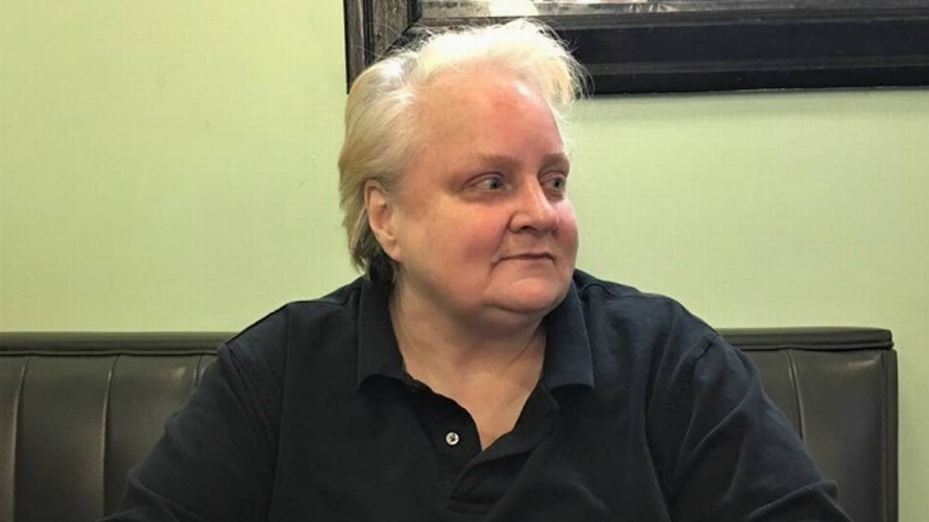
Candace Mercer is running for Olympia City Council Position 4 against incumbent Clark Gilman. COURTESY OF CANDACEMERCER.MEDIUM.COM/ABOUT
Editor’s note: This is one in a series of interviews with candidates running for Olympia City Council. At the end of each interview, The Olympian asked every candidate two questions: what they pay in rent or mortgage, and if they could correctly state the median home sale price in Olympia, which is $430,000.
Candace Mercer describes herself as “extremely low income, fully disabled with moderate to severe chronic pain+ for 20+ years, mentally ill, gender nonconforming, LGBTQ, a college dropout and someone who depends fully on the safety net for her survival.”
Although she has done activist work with the Rachel Corrie Foundation and Olympia Rafah Solidarity Mural Project, and as a rape crisis counselor, if you’ve heard of Mercer it’s probably from her polemical Medium essay, “The Real Crisis in Olympia is not Homelessness,” which accuses Olympia’s leadership of practicing “tolerance for harm” and ignoring “public drug use” in the name of progressivism.
Mercer was also featured on an episode of the KNKX/Seattle Times podcast “Outsiders,” as an example of how homelessness has warped the political commitments of a famously left-wing community.
Mercer is running for Olympia City Council Position 4 against incumbent Clark Gilman.
Although she says she is a progressive, Mercer voted for Donald Trump in the 2020 election, which she described as a performative “act of desperation and rebellion.”
“I am running because they have surrendered our city,” Mercer wrote in an email to The Olympian, referring to the current city council. When asked to whom the city is being “surrendered,” Mercer paused, then said she hadn’t fully thought that part out.
In an email the following week, Mercer wrote that she views the city’s response as giving up on rehabilitating people who are addicted.
“I see them accepting substance abuse and normalising it,” Mercer wrote. “Now that is very good on a population level, to reduce stigma, ABSOLUTELY, but it does not serve the individual well. That person needs paths out, not to be made comfortable with being addicted.”
Unlike other city council candidates who oppose the idea of harm reduction and propose a tougher approach to homelessness, Mercer has herself experienced housing instability. She receives $1,020 per month in disability pay and pays $1,150 per month in rent. In the past she has crowdfunded her rent payments and said she is unable to get on the section 8 waitlist. Recently she got rent assistance through federal stimulus money.
“I live completely on the edge. I have lived with housing instability all my life, but right now it’s closer than ever,” Mercer said. “I use the food bank, I use Union Gospel [Mission] to help pay my water bill. I use the safety net so I know intimately what works with the safety net, what the gaps are, what is really helping people and what is hurting them, what agencies treat you with respect and dignity, and what agencies don’t treat you well.”
Mercer says she has been alienated from the progressive community in Olympia for her views, but she rejects the idea that her run for office is motivated by that alienation. Still, it’s an overriding theme of her writing, and in an hour-long interview with The Olympian, she explicitly connected her own “cancellation” by the left with her turn towards conservatism.
Voting for Trump, Mercer said, both was a “meaningless act” in solid-blue Washington and a stunt meant to make a point about the perceived excesses of leftism.
“It was an act of desperation and rebellion. Because I’m seeing what damage has been done to my community, I’m seeing the division that’s being sown, I’m seeing what cancel culture is like, I’ve experienced that first hand. ...
“Because of speaking out and trying to write honestly about homelessness, I’ve lost about 80% of my personal communities. They all broke up with me because of trying to tell the truth and I think there’s some real damage being done by that. And because of what happened to my community and to me personally, for me to vote for the Democrats this year would — it would have felt like I was participating in my own debasement.”
Her “cancellation,” Mercer says, began with being “fired” from Works in Progress, for which she wrote a series of articles about the 2015 shooting of Andre Thompson and Bryson Chaplin by Olympia police officer Ryan Donald. She said the alternative newspaper told her not to write for them anymore after she wrote an article about a homeless encampment near her home.
In her essay, “Why I Voted Trump: A Coming Out Story,” Mercer issues her most direct rebuke of how she believes she’s seen by the progressive community in Olympia.
“I am not a RACIST WHITE SUPREMACIST TRANSPHOBE TERF ALT RIGHT CHUD and neither are you,” Mercer wrote in October 2020. “Yes, there are right wing extremists, but they are rare, and do not have much cultural influence. The torches did not come out again after Charlottesville.”
The tipping point that convinced her to vote for Trump, Mercer has written, was his executive order banning federal funds from being used to teach “critical race theory,” which she believes is “trying to remedy past discrimination with current discrimination.”
“Anything that teaches you to judge people on the color of their skin is at least discriminatory,” she said.
Asked if she believes her views represent Olympia residents, Mercer said she considers herself an “indie nonpartisan.”
“I have no affiliation to anyone right now because no one deserves my affiliation,” she said. “What I’m finding is that the political binary is almost obsolete.”

Meet Olympia City Council candidate Spence Weigand
BY BRANDON BLOCK
MAY 26, 2021 05:00 AM,
UPDATED MAY 26, 2021 10:01 AM
Spence Weigand is running for Olympia City Council Position 7. He will face incumbent Jim Cooper and Tyrone Dion Brown in the Aug. 3 primary. FACEBOOK
After a career at Costco, Spence Weigand moved back to Olympia from the East Coast in 1996, and has worked as a broker at Virgil Adams real estate since.
Weigand is running for Olympia City Council Position 7. He will face incumbent Jim Cooper and Tyrone Dion Brown in the Aug. 3 primary.
Weigand, who referred to himself as a “lifelong Democrat, not a Bernie Democrat, more of a Biden or Klobuchar type of Democrat,” flagged lack of affordable housing, struggling downtown businesses, and homelessness as Olympia’s top three issues.
In an interview with The Olympian, Weigand stressed the need for urban density, loosening regulations to encourage more housing development, and making downtown a more attractive destination for suburb dwellers.
“My big deal is, again, get more people downtown to support our businesses,” he said. “My wife and I, we are frequenters of downtown, and we feel safe — and we’re not gun owners, but we still feel safe — but I talk to so many people who don’t. And somehow we have to make downtown Olympia a little bit more inviting so that the entire community feels comfortable being there. And it will pay off in the form of more functioning, healthy businesses, higher tax base, more money in the city coffers.”
On affordable housing, Weigand cited statistics showing that 31% of Thurston County households are cost-burdened, which means spending more than 30% of their income on housing, and Thurston County’s expected population growth, which is 60,000 households over the next 25 years, according to the Housing Needs Assessment report.
That so much of people’s income is tied up in housing costs drags down the economy more broadly, Weigand said.
“That’s less money that they have disposably to spend at businesses downtown. Or saving to become future homeowners,” he said.
Weigand praised the recent zoning reform ordinance that effectively ended single-family zoning in Olympia, but said more needs to be done if the county is going to keep up with explosive growth, adding that “Olympia has a reputation for being difficult to deal with.”
Not only should projects like West Bay Yards be built, Weigand said, but multiply that by 20 to get the amount of new housing needed. (Weigand disclosed that his real estate firm was involved in listing the Hardel property.)
“My vision for Olympia is that we need to build up, not out,” Weigand said. “There’s been a groundswell of people in Olympia over the years that have been anti-growth in general, or growth paying for itself as it goes. And the problem is, we are going to grow whether we like it or not. And I just think that development, which sometimes carries a nasty connotation, connoting it with greed, is simply an accommodation of growth.”
Weigand fired off a list of ideas for reviving downtown, including creating a no-car zone and building an outdoor amphitheater as a performance destination.
Weigand used the term “enabling” to describe the city’s approach to people experiencing homelessness, and believes that Olympia’s robust social services are drawing people from outside the area. (In the 2020 Point-in-Time Count, three-quarters of homeless respondents listed their last known address as Thurston County or a neighboring county, with 61% listing Thurston County itself. Another 11% listed other Washington counties. Just 14% said they were from out-of-state.)
“We have to realize that we are not going to be able to build and spend our way out of this particular issue,” Weigand said, “and we have to find a way to keep the homeless population from the huge increases we’ve seen over the last 10 years.”
Asked what he means by “enabling,” Weigand referenced the sanitation facilities and cleanup efforts at the Deschutes Parkway encampment. While those efforts are “okay for now,” they are not a long-term solution.
“That’s just satisfying people who are up in arms about the environment and how it looks, and how it makes them feel,” Weigand said. “Even those who were involved in coming up with that [scattered site] proposal have acknowledged that there’s no guarantee there’s going to be an overall reduction in the number of people living in encampments or in vehicles.”
But Weigand did not go as far as to call for pressuring people living in homeless encampments into court-mandated treatment.
“I’m not necessarily in favor of going in and sweeping up the camps, but I would like to see a higher law enforcement presence on those items that are a result of the large homeless population we have around the downtown core,” Weigand said. “And by that I mean businesses that struggle to compete, particularly in the COVID period, property damage, violent crime — there’s been a big uptick.”
Weigand proposed non-punitive solutions, too, including building a new mental health treatment facility such as the 85-bed Providence mental health hospital planned for Lacey, and using rent assistance to prevent homelessness in the first place.
“Someone who has lost a job, or is a victim of domestic violence, or has huge medical bills and gets forced out of their home — it seems to me that it would be a lot more cost effective and less expensive in the long run than trying to figure out what to do with people once they are homeless,” he said.

WHAT DO YOU BELIEVE ARE THE ROOT CAUSES OF HOMELESSNESS?
“Lack of affordable housing, drug addiction and alcoholism, mental illness. ... I think what the city of Olympia needs to do is kind of take a triage approach to addressing homelessness. … Identify the people who are homeless, put a face and a name on them, identify them and triage the solutions. Because one solution is not going to fix the entire problem.”

Meet Olympia City Council candidate Corey Gauny
BY BRANDON BLOCK
MAY 28, 2021 05:00 AM

Corey Gauny is running for Olympia City Council position 6, which is being vacated by Renata Rollins. COREY GAUNY FOR OLYMPIA CITY COUNCIL
Editor’s note: This is one in a series of interviews with candidates running for Olympia City Council. At the end of each interview, The Olympian asked every candidate two questions: what they pay in rent or mortgage, and if they could correctly state the median home sale price in Olympia, which is $430,000.
Corey Gauny spent 22 years as a firefighter in the U.S. Air Force, where he lived in dozens of countries across Asia and Europe. He returned to Olympia in 2010, finished his bachelor’s degree and MBA at Pacific Lutheran University in Parkland, and now works for the Department of Licensing as a management analyst.
Gauny is running against Dontae Payne and Sarah DeStasio for Olympia City Council Position 6, which is being vacated by Renata Rollins.
In an interview with The Olympian, Gauny said he was motivated to run by seeing a disconnect between how city council talks about homelessness and what he’s personally observed and heard from neighbors.
“What we’re being told the challenge is and the problem is, is ‘Oh they’re marginalized people, we need to give them a break.’ And what we and the community members and constituents I talk to see is an increase in crime, an increase in violence and vandalism in our community, seeing needles in our public spaces, in our parks.”
Gauny, who described himself as a “Kennedy Democrat,” said he believes that Olympia is a “magnet” for people who are struggling with mental health issues or substance abuse disorder because of “strategies of no barriers,” and he is frustrated by council members’ unwillingness to express that sentiment.
Gauny said he believes the root cause of the majority of people experiencing homelessness is mental illness and substance abuse disorder, and he is frustrated by what he called a double standard in which people “rationalize illegal behavior.”
“No, you can’t burn in a burn bin in your yard but these people are allowed to down here,” Gauny said. “No, you can’t steal but these people can.”
Gauny said not all people experiencing homelessness are mentally ill or drug-addicted, just most of them.
“That makes up, according to some of the analysis I’ve seen, about 70-80%,” Gauny said. “We also have about 20-30% that I call marginally displaced, or people who are down on their luck.”
Asked what kind of intervention he would like to see, Gauny said he doesn’t want to see homeless people arrested, but rather issued citations or referred to the community court system to compel them into treatment.
“I would like to see more accountability for the violations of municipal codes, burning, occupation of private property. We’re not bashing people because they’re homeless, we’re forcing them to use the resources that are available to them to get them back on a productive course.”

WHAT DO YOU PAY IN RENT/MORTAGE?
His mortgage is $1,500 per month.

WHAT’S THE MEDIAN HOME PRICE IN OLYMPIA?
$350,000.

Meet Olympia City Council candidate Robbi Kesler
BY BRANDON BLOCK
MAY 24, 2021 12:47 PM,
- 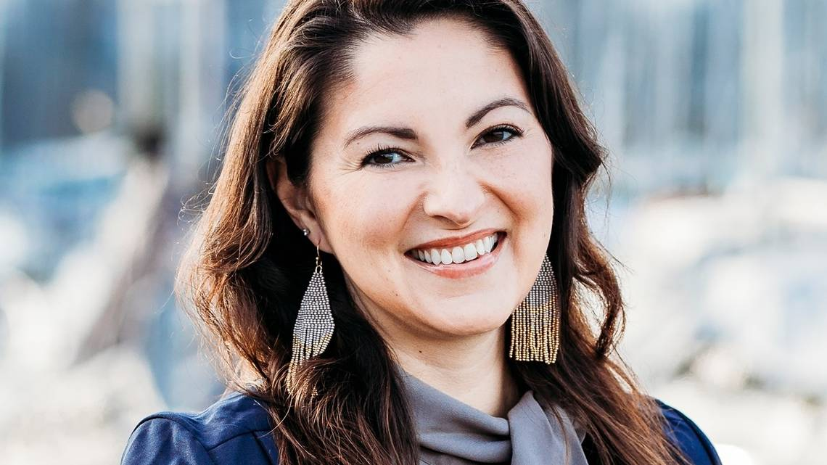
Robbi Kesler is running for Olympia City Council position number two. COURTESY OF KESLER FOR COUNCIL
Editor’s note: This is one in a series of interviews with candidates running for Olympia City Council. At the end of each interview, The Olympian asked every candidate two questions: what they pay in rent or mortgage, and if they could correctly guess the median home sale price in Olympia, which is $430,000.
Robbi Kesler is the former general counsel for the Confederated Tribes of the Chehalis, and has worked as nonpartisan counsel for the state House of Representatives. She is an enrolled member of the Skokomish Tribe in Mason County.
In an interview with The Olympian, Kesler touted her legal experience and unique perspective as a Native American woman as strengths she would bring to the council.
Kesler cited her involvement with lobbying the federal government to overturn a two-centuries-old law that prohibited liquor production on Indian reservations. The repeal of that law, which passed in 2018, three years after she left her position with the Chehalis for a job in state government, led to the opening of Talking Cedar Brew Pub and Distillery, the first native-owned distillery to open on tribal land in the nation, according to the Northwest News Network.
Kesler was one of eight finalists for Jessica Bateman’s open seat, to which Yen Huynh was appointed. In her application for that seat, Kesler wrote that her top three priorities were accountability for elected officials, affordable housing, and addressing the public health impacts of homelessness, including a “plan to remove trespassers from private property.”
“I think there are some gaps in the system that are allowing the city to kind of continue to put Band-aids on the situation and get into these stickier situations where it’s a property owner shouldering some of that burden,” Kesler said.
She thinks the city should focus on rapid rehousing and temporary shelters to get people off the streets quickly, citing a federal judge’s ruling in Los Angeles last month that requires the city to find shelter for more than 4,600 unhoused people on Skid Row within six months. (The Ninth Circuit Court of Appeals temporarily paused the order last week.)
“I think that needs to be a focus at this point, because it’s the right thing to do, but also because you’re going to see governments end up boxed into ‘this is what you must do’ and timelines that are set by courts and people outside of the community,” she told The Olympian.
Kesler criticized local officials for failing to find a long-term solution for RV dwellers, referencing a planned RV safe lot that was shelved at the end of 2020.
Another priority Kesler listed on her previous application was increasing funding for law enforcement. Asked to elaborate, she said that those funds would not necessarily go towards more police, but to other public safety initiatives, such as “additional efforts related to mental health or answering domestic violence calls.”
“It doesn’t have to be in the line item of the police department — maybe yes, maybe no — but some of these additional efforts in training and also creating programs that answer calls would require additional funding,” Kesler said.
Kesler supports the city’s reimagining public safety process, which she called “long overdue,” but didn’t offer specific ideas for police reform aside from what’s already being done.
Other priorities for Kesler include reducing impact fees for certain businesses such as childcare to encourage more businesses to open, as well as reducing barriers for property owners who want to build Accessory Dwelling Units or other infill housing.

HOW MUCH DO YOU PAY IN RENT/MORTGAGE?
Kesler owns her condominium outright, but pays $440 per month in homeowners association fees.

WHAT’S THE MEDIAN HOME PRICE IN OLYMPIA?
“$478,000, in the high $400,000s.”

Meet Olympia City Council candidate Wendy Carlson
BY BRANDON BLOCK
MAY 23, 2021 05:00 AM
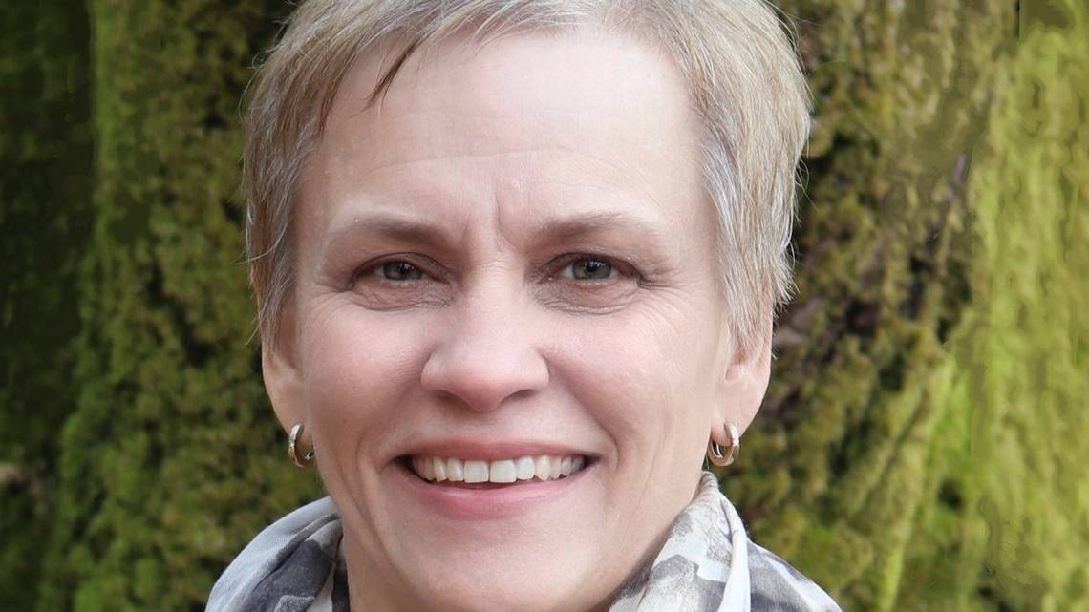
Wendy Carlson is running for Olympia City Council position 5. COURTESY OF WENDY FOR OLY COUNCIL
Editor’s note: This is one in a series of interviews with candidates running for Olympia City Council. At the end of each interview, The Olympian asked every candidate two questions: what they pay in rent or mortgage, and if they could correctly state the median home sale price in Olympia, which is $430,000.
Wendy Carlson worked for 20 years as a parole officer for the Department of Corrections. While several openly gay men have served on Olympia’s City Council, Carlson would be the first openly gay woman to do so.
Carlson is one of two challengers seeking Olympia City Council Position 5, a seat now held by Lisa Parshley. Talauna Reed also is challenging Parshley, so the field of candidates will be narrowed in the Aug. 3 primary.
In an interview with The Olympian, Carlson said she would leverage her experience working with former prisoners to bring “accountability” to people living in homeless encampments, who she believes are being enabled by overly tolerant leadership.
“I think there are plenty of people in this community that are tired. They, like me, grew up in Olympia, and see that Olympia is at risk,” Carlson said.
Asked what elements of the criminal justice system she’d like to bring to city government, Carlson said she doesn’t like to think of her work as a parole officer as being part of the criminal justice system.
“While we were an arm of it, the beauty of my job was, you could violate a condition, that I have the opportunity to say, ‘I know that you’re really trying … I know you had a positive [urinalysis], but I know you’ve been going to meetings, to treatment, so let’s maybe up your AA meetings or your NA meetings or your mental health treatment, and get you back right on the track.’
“It wasn’t about punishing them,” Carlson said. “It was really about getting them to be part of our community.”
Carlson said she’d like to expand the use of court-mandated treatment programs she believes are working, such as drug court, mental health court, and community court.
Programs that are not working, according to Carlson: the county’s “scattered site” plan, which will spend up to $1 million to clean up camps and hire case managers to connect residents to services.
“What are you getting for that?” Carlson said. “You can’t just throw money at stuff and hope that it’s going to change what’s going on.”
Carlson claimed that “there are smaller cities in this nation that have curbed their homeless population with little to no money.” Asked for an example, Carlson said she read “several months ago” about a city called Gainesville, Illinois, but there is no city in Illinois with that name.
Here are some other questions Carlson field during the interview with The Olympian:

WHAT DOES ‘ACCOUNTABILITY’ FOR PEOPLE EXPERIENCING HOMELESSNESS MEAN?
“I am very compassionate towards the homeless. I’ve worked with this population a lot in Seattle, they were on my caseload. While I’ve never been homeless, I understand the struggles that they go through. The accountability piece is: the hot topic is what has gone on on Deschutes Parkway — the debris and the litter that has gone on. Let’s make them part of the process of helping them keep their campsite clean. Getting them into a community court setting — that’s accountability.

WHAT DO YOU BELIEVE IS THE ROOT CAUSE OF HOMELESSNESS?
“I think most of it, we have vets that are homeless, families that are down on their luck, we have addicts, we have mentally ill — there’s a whole array, and it’s not a catch-all answer.”

WHAT DO YOU PAY IN RENT/MORTGAGE?
Carlson owns her home outright.

WHAT IS THE MEDIAN HOME SALE PRICE IN OLYMPIA?
“Well they just came out with the number, and I want to say it was $420,000 or $430,000.”

Meet Olympia City Council candidate Dontae Payne
By Brandon Block
June 03, 2021 05:00 AM
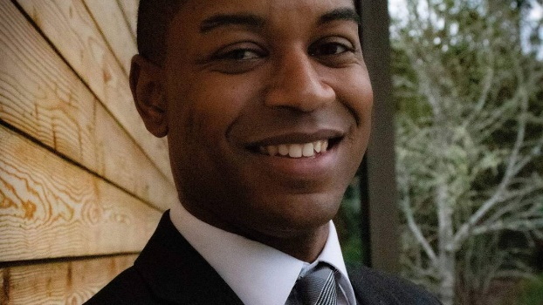\
Dontae Payne is running for Olympia City Council Position 6. Dontae Payne for Olympia City Council
Editor’s note: This is one in a series of interviews with candidates running for Olympia City Council. At the end of each interview, The Olympian asked every candidate two questions: what they pay in rent or mortgage, and if they could correctly state the median home sale price in Olympia, which is $430,000.
Dontae Payne grew up in Philadelphia. He joined the U.S. Army at age 23 and served two tours in Afghanistan, then re-enlisted at Joint Base Lewis McChord.
“There are a lot of people that say they joined the military because they wanted to serve their country,” Payne said in an interview with The Olympian. “And I do believe people when they say that. But you know, what I see it as is the military was a ticket to a life out of intergenerational poverty.”
Dontae Payne is running against Corey Gauny and Sarah DeStasio for Olympia City Council’s Position 6, which is being vacated by Renata Rollins. The field will be winnowed in the Aug. 3 primary.
Payne served in the Army during the latter days of the military’s Don’t Ask Don’t Tell policy, which was repealed in 2011. Although he said he never felt directly discriminated against for his sexual orientation, Payne described the experience of seeing Don’t Ask Don’t Tell reversed as his “first real introduction into the world of politics.”
After leaving the military in 2016, he finished his undergraduate studies and got a master’s degree in public administration at The Evergreen State College. He worked as the South Puget Sound regional representative for Gov. Jay Inslee and more recently as a Deputy District Director for U.S. Rep. Marilyn Strickland.
He was the treasurer of the Thurston County Young Democrats and is a member of Thurston County Queer Democrats.
Payne said he was motivated to run by, among other things, the lack of representation of Black and brown people in city government. Important issues to him include affordable housing, homelessness, and addressing political violence at the state Capitol Campus.
While he supports the current “reimagining public safety” process, he also hears skepticism from people of color and says time will tell if it actually produces tangible results or is simply a “box-check or something that is performative.”
Payne said he would focus on making it easier for Black people to open businesses, especially in the cannabis industry.
“For years, Black and brown people have been jailed for doing something that now the government itself has sanctioned,” he said.
On police reform, Payne proposes body cameras and implicit bias training, as well as a comprehensive review of the police department hiring process to make sure that officers understand the history of systemic racism in the U.S. He didn’t call for any specific changes to the police guild contract.
Payne is against defunding the police, which he called “a convenient distraction from white supremacy.”
“Instead of talking about truly getting systemic racism out of our policing agencies, what we are talking about is the budget,” Payne said. “As far as I’m concerned, we cannot afford to have a reduction in officers in this community because there is still regular crime and things that have to be addressed by our police, and so they are a necessary part of society.”
Payne said that Olympia needs more affordable housing and he wants to work with developers to incentivize building it, but stopped short of calling for mandates.
Payne said he’d like to see more tiny home villages like the one at Plum Street to help address homelessness.
He also wants to see harsher penalties for drug dealing in the downtown core, citing stories he hears from downtown business owners. “The drug issue is something that they’re fed up with, and they would like to see a council member who would stand up and actually, you know, deal with it.”
Payne distinguished between drug use, which he believes should be treated like a disease, and drug dealing, which he believes should be prosecuted as a crime.
“I do think that we have a drug problem that’s sort of masked itself and hidden behind our homeless population,” Payne said. “I’m not talking about those who use drugs, because I do understand that that is someone who needs help to be rehabilitated, and drug addiction is a disease, but for those who are selling it and distributing it to those vulnerable people, our police officers in Olympia should be allowed to do their jobs and punish people to the fullest extent of the law for that behavior.”

How much do you pay in rent/mortgage?
Payne says his mortgage is $1,696.20 per month.

What’s the median home price in Olympia?
$400,000

Brandon Block
360-754-5453
Brandon Block

Meet Olympia City Council candidate Talauna Reed
By Brandon Block
June 07, 2021 05:00 AM,
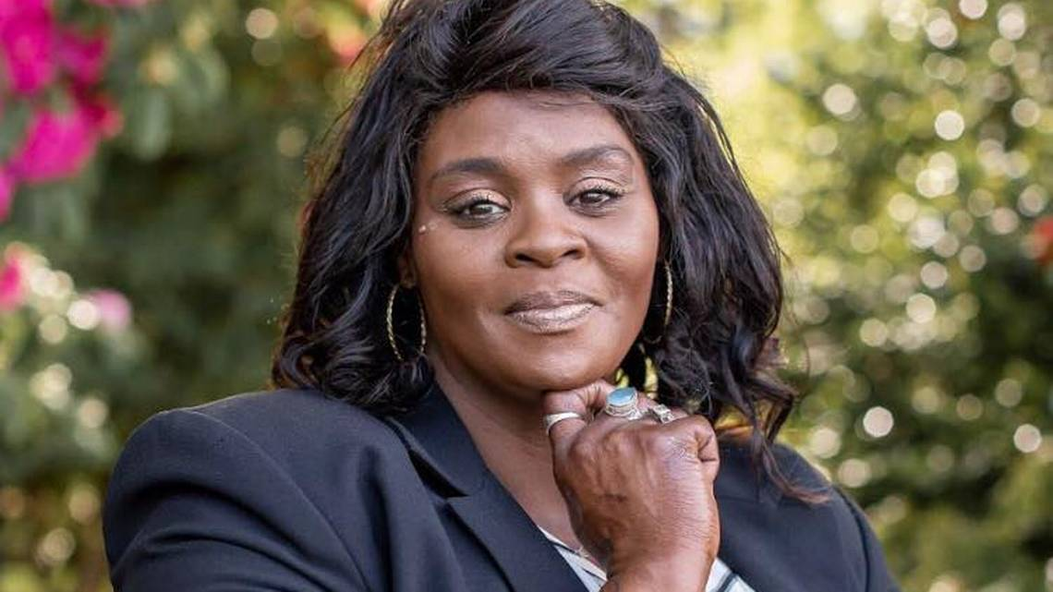
Talauna Reed is running for Olympia City Council Position 5 against Wendy Carlson and incumbent Lisa Parshley. Courtesy of Talauna Reed for Olympia City Council
Editor’s note: This is one in a series of interviews with candidates running for Olympia City Council. At the end of each interview, The Olympian asked every candidate two questions: what they pay in rent or mortgage, and if they could correctly state the median home sale price in Olympia, which is $430,000.
Talauna Reed remembers the exact day she decided to run for Olympia City Council.
It was June of 2020, shortly after the murder of George Floyd, and Reed, who was already a recognizable figure from her activism around the death of her aunt, Yvonne McDonald, was listening to Olympia Mayor Cheryl Selby speak.
“We need people of the color to not just be at the table, we need you at the head of the table,” Selby said at the time, during a press conference outside City Hall.
To Reed, it sounded like an invitation, but one that has since proved difficult to redeem.
Reed is now running for Olympia City Council Position 5 against Wendy Carlson and incumbent Lisa Parshley. The field will be winnowed in an Aug. 3 primary.
In one of Reed’s campaign videos, she is jogging when she gets an unexpected phone call directing her to come down to City Hall immediately. But when she gets there, the doors are locked. Confused, Reed then opens her phone and shows the video of Selby’s speech to a passerby (played by another candidate, Sarah DeStasio).
“Each one of them has said, we need people of color at the heads of the table, at the decision-making table,” Reed said in an interview with The Olympian. “In my opinion, they’re trying to pick what types of people of color they want there, ones that conform to their way of thinking. … Their idea is someone of color who is more passive, I guess, or who won’t go against them.”
That the doors of City Hall are locked when Reed gets there symbolizes the provocation she has spent the past several years refining as an activist and frequent public commenter at council meetings. It goes something like this: “You (the mayor, city leadership) say you want Black women in charge. Do you really mean it?”
If elected, Reed would be the second Black woman to serve on Olympia City Council. Cora Pinson, the first and only Black woman to serve, held her seat between 1987 and 1991, according to the city’s Heritage Commission.
Reed is running against incumbent Parshley, but said she doesn’t have anything against Parshley specifically, but chose the seat by process of elimination because she didn’t want to run against another person of color. Dontae Payne announced his candidacy for Renata Rollins’ Position 6 seat the same week Rollins said she wouldn’t run for re-election.
Reed, who works on staff at the Interfaith Works homeless shelter, and formerly at the Salvation Army shelter, said her interest in activism began with the death of McDonald.
In 2019, she closed the wig and beauty supply store she owned in Lacey and poured her energy into attending city council meetings. She organized a movement called Justice for Yvonne McDonald that has called for an independent investigation into her aunt’s death, which she believes was the result of “racist negligence.”
Around that time, she started an event during the holiday season called the Joy and Justice book giveaway. Reed credits her friendship with Crystal Chaplin — whose sons, Andre Thompson and Bryson Chaplin, were shot by Olympia Police Officer Ryan Donald — with motivating her activism.
Reed’s agitation around her aunt’s case and the movement she leads is rarely addressed at council meetings, even when allies speak at public comment. By Reed’s estimation, Rollins was the only council member to ever respond directly to her comments.
“I would speak, and they wouldn’t address me,” Reed said. “I was a part of SURJ (Showing Up for Racial Justice) and the idea I came up with was having white folks amplify the need for justice, because the city responded to my white peers when they would go speak to them.”
Reed said that the experience of being stonewalled in her efforts to get answers about her aunt’s case led to her belief that the current council were prioritizing their own careers over confronting the possibility that wrongdoing played a part in her aunt’s death.
Reed’s advocacy has put her at odds with city council members and city officials — especially current city manager Jay Burney, who she has criticized in public forums and who the organization BLAST (Black Leaders in Action and Solidarity in Thurston County) has called on to be fired.
“I go hard at the council because that’s their position,” Reed said. “They’re there for people, and they should be held to a higher standard than anybody. But when I seem so argh against them, it’s not because I hate the people. I don’t dislike the people, I dislike the system that is in place that for years has perpetuated this and drawn people that will not stand up for the public to those positions. Obviously they’re engulfed in the system and we just can’t get anybody in there to shake that whole culture and stand up for people.”
Since her campaign began, Reed has broadened her message, taking on issues such as homelessness, police reform, and economic inequality, earning her endorsements from the Thurston County Progressives and the Olympia chapter of the Democratic Socialists of America.
“I purposefully haven’t really talked a lot about Yvonne’s case during the campaign,” Reed said, “because I kind of want to, not that I’m not going to, I will, but I want folks to realize there’s not just one issue that I support.”
Housing is another issue where Reed’s agenda flows directly from her own experience.
In an interview, she described a lifetime of housing insecurity: having to move on short notice, receiving 20-day notices (which have since been banned statewide by the recent just-cause bill), and being charged screening fees, security deposits, and other fees she described as excessive when applying to apartments.
Those struggles are part of what qualifies her, Reed said.
“People want to see some type of results, and want to see some change,” Reed said. “It’s like, I’m here, and I want to be a part of that. I think that, just my background and my experience alone — I’ve been homeless, I’ve gone through treatment in different phases of my life, I’ve been the victim of domestic violence, I’ve gone through so many things that — am I the only voice, no — but I’m very comfortable sitting with marginalized people, vulnerable people.”
Reed’s big idea is to create a city housing authority, which would facilitate the construction of public and nonprofit-owned housing. She wants to pass stronger renter protection policies that would cap security deposits and move-in fees, and proposed a landlord registry for better oversight of predatory practices.
Reed has called for “meaningful cuts” to police spending and a freeze on hiring new officers. That money could be redirected to the Crisis Response Unit and a fund for victims of crimes, especially victims of police violence. On her website, she pledged to create a citizen oversight committee with power to trigger an investigation into police misconduct.

How much do you pay in rent/mortgage?
Reed’s rent is $1,180 per month.

What’s the median home price in Olympia?
“I think it’s around $430,000?”

Meet Olympia City Council candidate Bruce Wilkinson Jr.
By Brandon Block
June 14, 2021 05:00 AM,
Bruce Wilkinson, Jr. is running for Olympia City Council position 2. Northwest Alliance for Alternative Media and Education
Editor’s note: This is one in a series of interviews with candidates running for Olympia City Council. At the end of each interview, The Olympian asked every candidate two questions: what they pay for housing, and if they could correctly state the median home sale price in Olympia, which was $430,000 when this series began but has since climbed to $452,000.
Bruce Wilkinson Jr. is a bus driver for North Thurston Public Schools, a union member, and an arborist on the side.
He is running for Olympia City Council Position 2 against Yến Huỳnh and Robbi Kesler. He filed his candidate papers on the last day before the deadline. His entry into the race means there will be a primary for Position 2, which was vacated by Jessica Bateman at the end of 2020.
Wilkinson was born in Virginia, grew up in Kentucky, and moved to Washington in 2003 to do an AmeriCorps fellowship. He studied political economics at The Evergreen State College and has lived in Olympia since.
Over the course of about seven years, Wilkinson estimated that he’s put on more than 100 events in Olympia as a community organizer with groups like Media Island International.
In 2012, Wilkinson organized Power to the Public, a ballot initiative that would have allowed the Thurston County Public Utility District to create a public electricity provider, as 24 counties in Washington do, including Mason, Grays Harbor, Pacific, and Lewis. The initiative, which failed with 40% of the vote, was in response to Puget Sound Energy, the only utility company that serves Olympia, being bought by a foreign investment bank in 2009.
While he has never run for office before, Wilkinson managed the unsuccessful 2014 U.S. Senate campaign of Charlie Hardy, a former Roman Catholic priest who has been called “the Bernie Sanders of Wyoming.”
“For years and years I’m sort of a person who was on the ground showing up for various causes, helping to organize in the background, from labor protests at the Capitol to Occupy Olympia, and showing up for all sorts of things since then, fighting budget cuts on the state level.”
He will face Huỳnh, who was appointed to fill Bateman’s seat in January, and Kesler, who was a finalist for that appointment but lost to Huỳnh. He said he chose Position 2 because he supports Sarah Destasio for Position 6 and Clark Gilman for Position 4, and the other races had at least three candidates already.
“I’ve been telling people for years that we need to have more grassroots organizers run for office, and if you tell people that but you don’t do it yourself, then I think you’ve got to put your money where your mouth is to some degree,” Wilkinson said. “So that’s what I did.”
In an interview with The Olympian, Wilkinson positioned himself to the left of Huỳnh and Kesler, who he described as part of the “professional class.”
“I just have trouble with, because I know they probably think of themselves as progressives, and I think a lot of people probably do think of them as progressives … I’m kind of a blue-collar, working-class guy. And I feel like they’re part of the professional class, which is fine, but it’s a different perspective on things.”
Wilkinson said he is running to call attention to rapidly rising rents and the increasing commoditization of housing, which he blames on “out-of-town investors” speculating on property.
“We definitely need to build housing, you know — people are saying there’s a shortage and I think that’s true,” he said.
“But I also feel like if we keep building housing that keeps getting bought by outside investors and put into large property management funds, then these property management funds have such a large share of the market that they can arbitrarily set the rental prices higher. And there’s no amount of building houses, as long as that model is there to buy them up, that can get us out of the situation of higher rental prices.”
Wilkinson, who is a lifelong renter, called for more protection for renters, including banning application fees and limiting security deposits.
He proposed a tax on owners of vacant property and pledged to end tax breaks and “sweetheart deals” for developers. Asked if there were specific programs he would get rid of, he cited a 12-year property tax exemption for downtown properties that sounded like the Multifamily Tax Exemption, although he did not name it as such.
“They should be paying full price if they’re going to build in this town,” Wilkinson said. “If we do incentivize anybody, it should be young people who are trying to buy their first homes in this town.”

How much do you pay for housing?
His rent is $600 per month.

What’s the median home sale price in Olympia?
“I think 4 something, early $400,000s, $400,000-450,000?”

Meet Olympia City Council candidate Tyrone Brown

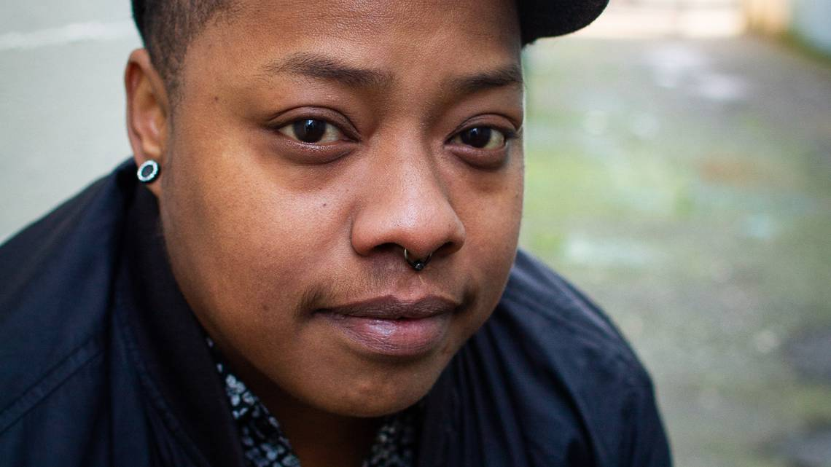
Editor’s note: This is one in a series of interviews with candidates running for Olympia City Council. At the end of each interview, The Olympian asked every candidate two questions: what they pay for housing, and if they could correctly state the median home sale price in Olympia, which was $430,000 when this series began but has since climbed to $452,000.
Tyrone “Ty” Dion Brown estimates he became a housing activist around age 14. He grew up in Portland, Oregon, amidst the backdrop of an increasingly gentrified city that eventually pushed his family out when he was 17.
Roughly a decade of housing insecurity followed: He slept on friends’ couches, in shelters, and on the streets. About six years ago, Brown moved to Olympia, where a friend lived, attracted by the “small town vibes.”
Brown has worked as a cook, started a catering business and jewelry business, and made clothing and art. For the past several years, he has worked as a community and tenant organizer, first for Washington Community Action Network (WCAN) and now for the Tenants Union of Washington.
Brown said he got into tenant organizing after he and his three children were evicted without cause from an apartment they’d lived in for four years. After a neighbor contacted a tenants rights group, they were able to get some extra time to move.
“Being a single parent and working 2, 3 jobs, I didn’t have time to even look to see if this was legal,” Brown said. “I had no idea at the extent to which evictions follow [you] and how easy it is for anyone to get evicted, but especially BIPOC people, people with children, people who don’t have a whole lot of money.”
Brown said he was motivated to run in part to hold the city accountable to its stated commitment to equity. He described attending many city council meetings in his role as a tenant organizer and seeing a “lack of representation and lack of real understanding” on the current council.
“There always seems to be this disconnect between policy-making resources and the marginalized community, the BIPOC community. So bridging that gap, that would be definitely one way to bridge that gap is by electing BIPOC community members,” Brown said.
Brown is running for Position 7 against Spence Weigand and incumbent Jim Cooper. He said he chose that seat because Dontae Payne and Talauana Reed, who are both Black, had already registered to run for other seats.
While he said he doesn’t have anything against him specifically, Brown noted that Cooper has been in office for nine years and he believes in “getting fresh new faces in there and shifting the dynamics of power.”
Last October, Brown, who organizes with Black Leaders in Action and Solidarity in Thurston County (BLAST), was part of a coalition that pushed the city to pass emergency renter protections. That ordinance extended a ban on evictions for unpaid rent for as long as Gov. Inslee’s declared state of emergency continues, but not longer than October 2021. BLAST had previously called on the city to pass legislation preventing landlords from evicting tenants over COVID-era debt.
Brown wants the city to further protect renters by restricting application fees, creating a universal application process, strengthening “just cause” eviction protections beyond the recent changes to state law, and passing Tenant Opportunity to Purchase (TOPA) legislation on a local level.
“The [eviction] moratorium will be lifted on June 30, and although we do have policies set into place that we recently just won in the tenant advocacy world, such as just cause and (SB) 5160 (tenant right to counsel), there are still many loopholes and many resources that haven’t been put into place, so people are still going to be facing evictions and instability.”

WHAT DO YOU PAY FOR HOUSING?
His rent is $1,275.

WHAT IS THE MEDIAN HOME SALE PRICE IN OLYMPIA?
$430,000

